The Report

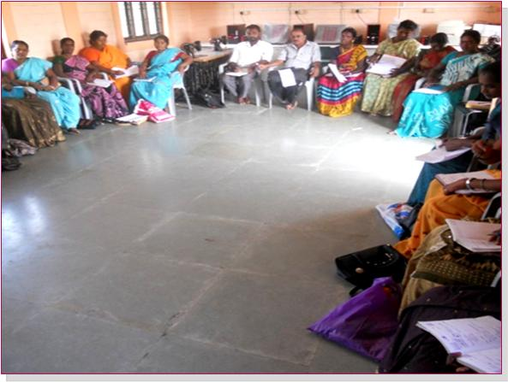

Annie Valsarajan
Independent Consultant
2012/13

Report of the Nutrition Training
for the
Health Workers of CRUSADE
Day One (11th Nov 2012)
Centre for Rural System & Development (CRUSADE) a development organisation founded in 1991, aims at poverty reduction and social advancement of marginalised poor in Tamilnadu. With the vision of enabling the poor and marginalized sections of the population in villages around Minjur and Sholavaram blocks of Thiruvallur District, CRUSADE reaches out to around 2,00,000 people.
CRUSADE launched a health programme namely TAMWED for imparting Health Education to all SHG members at village level through the field staff and Federation Volunteers.
Recognising the importance of nutrition for good health and wellbeing, CRUSADE decided to organise a training programme on nutrition for their health staff. After discussing on the need and objective of the training with Mr. JothiRamalingam, Secretary, CRUSADE, the responsibility of organising the training was entrusted to Ms. Annie Valsarajan, an Independent Consultant for Development Programmes. The content, methodology, duration, venue and the dates were finalised with mutual consent.
Participants:
The participants consisted of 3 male Co-ordinators, 2 Block Co-ordinators, 6 Sector level Coordinators & 12 Health Volunteers. Altogether there were 23 participants from Minjur & Sholavaram Blocks of Thiruvallur District.
Methodology:
It was mostly participatory with group discussions, brain storming sessions, lecture cum discussions and practical homework assignments.
Inauguration:
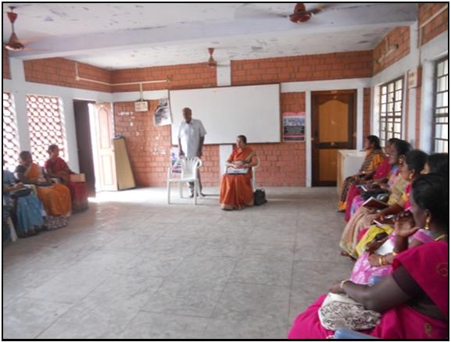
The programme was inaugurated by Mr.Jothiramalingam, Secretary, CRUSADE at the Centre’s Office at Karanodai, Sholavaram Block at 11 am. He reminded the participants of the 4 objectives of TAMWED project namely, helping the people to access basic health services, create awareness about the climatic changes, sensitise them on the importance of environmental sanitation, increase the food production & improve food practices. He reiterated the urgent need to bring about a favourable change in dietary habits due to emerging health problems such as obesity, hypertension, diabetes & cardiac problem besides undernutrition & anaemia. He said that as Health Workers & Volunteers they have to constantly and continuously educate the people on the importance of proper nutrition. He requested the participants to take this opportunity to learn and utilise the knowledge in the field.
Session 1:
Introduction of participants:
The participants were divided into 7 groups. Each group was given a topic for discussion. They were asked to discuss & present the report. The topics for discussion are as follows:
- In your village what are the most preferred food among children and young people?
- What are the various changes in the food practices found in your village?
- What are the various cereals available in your place? What are the most preferred & consumed cereals?
- What are the various fruits available in your place? What are the most preferred & consumed fruits?
- What are the various vegetables available in your place? What are the most preferred & consumed vegetables?
- What are the various food forbidden or restricted for consumption due to food taboos & wrong beliefs?
- What are the nutrition problems found in your place?
- This exercise gave the participants an opportunity to interact with each other. It was a good ice breaking exercise.

Pre training evaluation:
In order to know the knowledge level, 10 questions were read out & the participants were asked to write the answers on a paper & the answer papers were collected & distributed among them (each participant will get the answer sheet of some other participants) and the right answers were read out for correction. The following are the pre evaluation questions:
- Among all vegetables available in your area which is the vegetable having high nutritive value?
- Among all fruits available in your area which is the fruit having high nutritive value?
- What is the nutrient required for growth?
- If there is a visitor in your household, which vegetable you would prefer to cook & serve?
- During pregnancy what should be weight gain for the pregnant woman?
- What is the disease caused because of iron deficiency?
- What are the micronutrients?
- What is the tablet distributed to adolescent girls to prevent anaemia?
- How long the new born babies should be given breast milk exclusively?
- From which month the baby should be given additional food along with breast milk?

Most of the participants scored 2 to 6 out of ten, revealing that the pre training knowledge level of the participants on nutrition was found to be very low.

Expectations of the participants:
This was followed by a brain storming session to understand their expectations from the training by the participants. Each individual participants were asked to tell their expectation which was written on the white board. The most mentioned answers are given below:
To learn the,
- Nutritive value of food stuff which are locally available
- Common nutrition problems & how it affects the health
- Easy to make nutritive recipes
- Proper cooking methods
- Enhancing nutritive value of food
- Practice the right food habits
- Collaborate with Government Departments such as ICDS, Public Health etc. which are implementing nutrition programmes.
After the lunch the sessions continued.
Session 2:
Common Nutrition problems:
The participants were sensitised about the following common nutrition problems in our country (Source NIN report 2010). The following table was written on the white board.
Children:
Children born with Low birth weight (LBW) - 20%
Children who do not have adequate weight
(Malnourished – 0 to 3 yrs) - 33%
Children who are anaemic (6 months to 59 months) - 70%
Children who are obese - 6 – 30%
Women (Anaemia):
Among pregnant women - 70%
Women of other age - 75%
Problem of obesity:
Men in rural areas - 7.8%
Women in rural areas - 10.9%
Tribal men - 3.2%
Tribal women - 2.4%
Urban men - 36%
Urban women - 40%
Diabetes:
Urban - 16%
Rural - 5%
Hypertension:
Urban - 16.5%
Rural men - 25%
Rural women - 24%
Tribal men - 25%
Tribal women - 23%
Heart diseases:
Urban - 7-9%
Rural - 3-5%
Cancer (out of 1, 00,000 populations):
Men - 113
Women - 123
Common causes of nutrition related problems:
- Largely a result of dietary inadequacy and unhealthy lifestyles
- Poor purchasing power
- Faulty feeding habits
- Large family size
- Frequent infections
- Poor health care
- Inadequate sanitation
- Gender bias
- Low agricultural production
Population living in the backward and drought-prone rural areas and urban slums, and those belonging to the socially backward groups like scheduled castes and tribal communities are highly susceptible to under nutrition. Similarly, landless labourers and destitute are also at a higher risk.
The participants were neither aware of such problems nor did they know that most health problems were due to malnutrition. This session provided an opportunity for the participants to get to know some of the common nutrition problems but also understand that it is one of their responsibilities to prevent such problems occur in their area.
Day Two (1st Dec 2012)
Session 1: Introduction to nutrition:
Venue: Pudupakkam
In this session the participants were taught about the importance of good nutrition for a health and wellbeing. The relationship between health and nutrition were explained though lecture cum discussion.
Nutrition is a basic human need and a prerequisite to a healthy life. It is the intake of food, considered in relation to the body’s dietary needs. Good nutrition – an adequate, well balanced diet combined with regular physical activity – is a cornerstone of good health. Poor nutrition can lead to reduced immunity, increased susceptibility to disease, impaired physical and mental development, and reduced productivity.

Nutrition is a critical part of health and development. Better nutrition is related to improved infant, child and maternal health, stronger immune systems, safer pregnancy and childbirth, lower risk of non-communicable diseases (such as diabetes and cardiovascular disease), and longevity.
Malnutrition, in every form, presents significant threats to human health. Today the world faces a double burden of malnutrition that includes both under nutrition and overweight, especially in developing countries.
Nutrients that we obtain through food have vital effects on physical growth and development, maintenance of normal body function, physical activity and health.
Nutritious food is, thus needed to sustain life and activity. Our diet must provide all essential nutrients in the required amounts.
After a brief introduction on the importance Nutrition, 2 volunteers, one male & one female, were asked to tell what they ate, how much they ate and how many times they ate from the time they got up in the morning till they went to the bed on the previous day. As they narrated, it was written in the white board. The participants were informed that one day diet of 2 volunteers will be analysed at the end of the session.
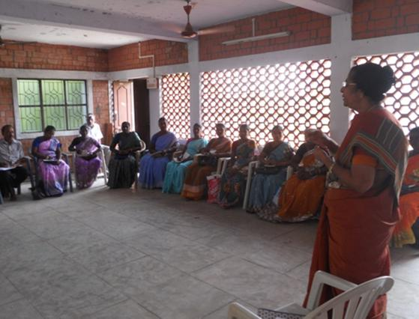

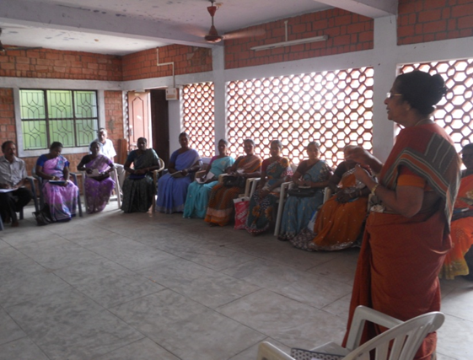
This exercise was followed by a lecture cum discussion on the functions of food in the human body,
Functions of food in a nut shell:
- For providing energy for doing work
- For growth or body building and for repair of tissues
- For help the body function properly & to protect from diseases.
Session 2:
Important nutrients:
- Carbohydrate
- Proteins
- Fats & oils
- Vitamins
- Minerals
Almost all food contains more than one of these nutrients. There is no one food in nature which contains all nutrients. For good nutrition we need to eat different kinds of food. Carbohydrates, fats and proteins are macronutrients, which are needed in large amounts. Vitamins and minerals constitute the micronutrients and are required in small amounts. These nutrients are necessary for physiological and biochemical processes by which the human body acquires, assimilates and utilizes food to maintain health and activity.
Carbohydrates:
Carbohydrates are major sources of energy in all human diets. They provide energy of 4 Kcal/g. The simple carbohydrates, glucose and fructose, are found in fruits, vegetables and honey, sucrose in sugar and lactose in milk, while the complex polysaccharides are starches in cereals, millets, pulses and root vegetables and glycogen in animal foods.
In India, 70-80% of total dietary calories are derived from carbohydrates present in plant foods such as cereals, millets and pulses. Diets rich in complex carbohydrates are healthier than low-fibre diets based on refined and processed foods.
All cereals and grains, sugar & sugar products, starchy vegetables such as potato, tapioca, yam, sweet potato, fruits such as banana, mango, all oil products such as butter, ghee, vegetable oils are rich in carbohydrate.
Proteins:
Proteins are essential for growth, for making many different kinds of cells, tissues and organs of the human body. Those who are injured or some disease which attacks body cells need extra proteins for repair of tissues and rebuilding. Similarly growing infants, pregnant women, nursing mothers and adolescent girls require extra amount of protein.
Proteins are complex molecules composed of different amino acids. Certain amino acids which are termed “essential”, have to be obtained from proteins in the diet since they are not synthesized in the human body. Other nonessential amino acids can be synthesized in the body to build proteins.
Animal foods like milk, meat, fish and eggs and plant foods such as pulses and legumes are rich sources of proteins. Animal proteins are of high quality as they provide all the essential amino acids in right proportions, while plant or vegetable proteins are not of the same quality because of their low content of some of the essential amino acids. However, a combination of cereals, millets and pulses provides most of the amino acids, which complement each other to provide better quality proteins.
Fats:
Oils and fats such as butter, ghee and vanaspathi constitute dietary visible fats. Fats are a concentrated source of energy providing 9 Kcal/g, and are made up of fatty acids in different proportions. Dietary fats are derived from two sources viz. the invisible fat present in plant and animal foods; and the visible or added fats and oils (cooking oil). Fats serve as a vehicle for fat-soluble vitamins like vitamins A, D, E and K and carotenes and promote their absorption. They are also sources of essential polyunsaturated fatty acids. It is necessary to have adequate and good quality fat in the diet with sufficient polyunsaturated fatty acids in proper proportions for meeting the requirements of essential fatty acids. The type and quantity of fat in the daily diet influence the level of cholesterol and triglycerides in the blood. Diets should include adequate amounts of fat particularly in the case of infants and children, to provide concentrated energy since their energy needs per kg body weight are nearly twice those of adults. Adults need to be cautioned to restrict intake of saturated fat (butter, ghee and hydrogenated fats) and cholesterol (red meat, eggs, organ meat). Excess of these substances could lead o obesity, diabetes, cardiovascular disease and cancer.
Vitamins:
Vitamins are chemical compounds required by the body in small amounts. They must be present in the diet as they cannot be synthesized in the body. Vitamins are essential for numerous body processes and for maintenance of the structure of skin, bone, nerves, eye, brain, blood and mucous membrane. They are either water soluble or fat- soluble. Vitamins A, D, E and K are fat-soluble, while vitamin C, and the B-complex vitamins such as thiamine (B1 ), riboflavin (B2 ), niacin, pyridoxine (B6 ), folic acid and cyanocobalamin (B12 ) are water soluble. Pro-vitamin like beta-carotene is converted to vitamin A in the body. Fat soluble vitamins can be stored in the body while water-soluble vitamins get easily excreted in urine. Vitamins B-complex and C are easily destroyed by heat, air or during drying, cooking and food processing.
Fat soluble Vitamins:
Vitamin A: is needed for,
- Healthy eyes
- Healthy skin and mucous membrane
If a person does not have enough Vitamin A, he/she gets night blindness, then dry eye and many become blind. Vitamin A is found in fish, egg, butter, milk green leafy vegetables and yellow fruits & vegetables
Vitamin D:
- Helps calcium & phosphorus to build bones & teeth.
- Helps child to grow
Sunlight the cheapest & best source of Vitamin D. Fish liver oil, butter, ghee yoke are also rich in Vitamin D.
Vitamin E:
Vitamin E is essential for normal reproduction. Vegetable oil, soybeans, ground nut, whole cereal egg, meat and fish are rich source of Vitamin E.
Vitamin K:
Vitamin K is necessary for blood clotting. Dark green leafy vegetables, pulses, cereals & fruits are good source of Vitamin K.
Water soluble Vitamins:
Vitamin C:
- Keeps body tissues intact
- Helps in repair of tissues
- Protects body against infection
- Helps to absorb iron.
Drumstick leaves, amla, bitter gourd, guava, lemon, orange, tomatoes, sprouted gram are rich source of Vitamin C. This vitamin is easily destroyed by heat, light & drying.

Vitamin B1 & B2:
- Required for metabolism of carbohydrate
- For nerve impulse
- Healthy eyes & mouth.
Dried yeast, wheat germs, green leafy vegetables, milk, egg & liver are good source of these vitamins
Folic acid:
Needed for making red blood cells specially during pregnancy. So pregnant mothers are given 100 iron & folic acid tablets during pregnancy which has to be taken 1 per day.
Minerals:
Minerals are inorganic elements found in body fluids and tissues. The important minerals are sodium, potassium, calcium, phosphorus, iodine and iron. They are required for maintenance and integrity of skin, hair, nails, blood and soft tissues. They also govern nerve cell transmission, acid/base and fluid balance, enzyme and hormone activity as well as the blood- clotting processes.
Calcium:
Calcium is present in large amounts in our bones & teeth. Therefore calcium is needed for pregnant & lactating women & growing children. Calcium is essential for (a) formation of bones & teeth, (b) clotting of blood, (c) strength of capillary walls, (d) contraction of heart muscle & skeletal muscles and (e) correct functioning of nerves. Milk, ragi, small dried fish, green leafy vegetables are good source of calcium.
Phosphorous:
Phosphorous is needed with calcium to form bones and teeth. It is required for carbohydrate metabolism. Milk, meat fish, eggs, nuts, grains, green leafy vegetables are rich in phosphorous.
Sodium chloride:
Sodium chloride which is commonly known as common salt is required to help regulate the fluid balance.
Potassium:
Potassium is required to regulate the tissue cell contents. Potassium is present in cereals, millets, pulses, vegetables, fruits, milk, meat, fish and liver.
Iodine:
Iodine is a mineral found in some foods. The body needs iodine to make thyroid hormones. These hormones control the body's metabolism and many other important functions. The body also needs thyroid hormones for proper bone and brain development during pregnancy and infancy. Getting enough iodine is important for everyone, especially infants and women who are pregnant.

In pregnant women, severe iodine deficiency can permanently harm the foetus by causing stunted growth, mental retardation, and delayed sexual development. Less severe iodine deficiency can cause lower-than-average IQ in infants and children and decrease adults' ability to work and think clearly. Goitre, an enlarged thyroid gland, is often the first visible sign of iodine deficiency. In order to tackle the problem of iodine deficiency, the common salt is fortified with iodine, which is available in the market. Government supplies iodised crystal salt through PDS. Using adequately iodised salt regularly in the diet is the only way to get adequate iodine for the body.
Iron: (Iron is explained in detail under the notes on ‘Nutrition for adolescent girls’)
Session 3: Food groups:
- Cereals and millets
- Pulses & legumes
- Vegetables
- Fruits
- Milk & milk products, egg, meat and fish
- Fats, oils, nuts & oil seeds

Importance of consuming nutritiously adequate diet:
- Nutrition is a basic prerequisite to sustain life.
- Variety in food is not only the spice of life but also the essence of nutrition and health.
- A diet consisting of foods from several food groups provides all the required nutrients in proper amounts.
- Cereals, millets and pulses are major sources of most nutrients.
- Milk which provides good quality proteins and calcium must be an essential item of the diet, particularly for infants, children and women.
- Oils and nuts are calorie-rich foods, and are useful for increasing the energy density.
- Inclusion of eggs, flesh foods and fish enhances the quality of diet. However, vegetarians can derive almost all the nutrients from diets consisting of cereals, pulses, vegetables, fruits and milk-based diets.
Vegetables and fruits provide protective substances such as vitamins/minerals/ phytonutrients.
Diversified diets with a judicious choice from a variety food groups provide the necessary nutrients.

Classification of food based on function:
Major Nutrients | Other Nutrients
 | Carbohydrate and fats
Energy rich foods | Whole grain cereals, millets | Protein, fibre, minerals, calcium, iron &B-complex vitamins
 | Vegetable oils, ghee, butter | Fat soluble vitamins, essential fatty acids
 | Nuts and oilseeds | Proteins, vitamins, minerals
 | Sugars | Nil
 | Proteins
Body building foods | Pulses, nuts and oilseeds | B-complex vitamins, invisible fat, fibre
 | Milk and Milk products | Calcium, vitamin A, riboflavin, vitamin B
 | Meat, fish, poultry | B-complex vitamins, iron, iodine, fat
 | Vitamins and Minerals
Protective Food | Green leafy vegetables | Antioxidants sugar and antioxidants
 | Other vegetables and fruits | Fibre, sugar and antioxidants
 | Eggs, milk and milk products and flesh foods | Protein and fat
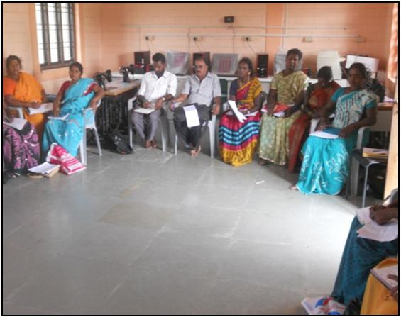
At the end of the session, having learnt about the importance of nutrients and its functions in the body and the different food groups, the participants were asked to analyse the “one day diet” of 2 participants which was written on the white board. The following were the observations:
- The diet mainly consisted of rice and it was taken atleast 3 times a day
- Consumption of pulses, vegetables & fruits were almost nil or minimal.
- Practice of consuming other cereals such as ragi, wheat, jowar, bajra which are available locally was not found.
- Preference given for fried food & consumption of oil is high.
A view of Participants

Day three (15/12/2012)
Session One: Food pyramid:
Venue: Pudupakkam
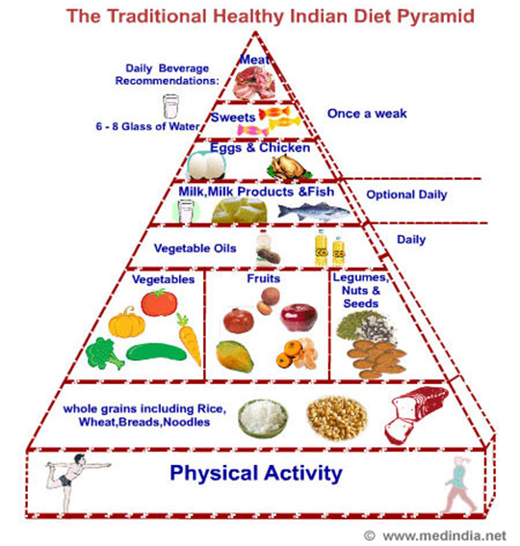

With the help of the above picture of food pyramid, the need for including right amount of different food groups was explained. However, the food pyramid may vary according to the age & other special situations. For example the diet of a pregnant & lactating mother should include more of cereals, pulses and vegetables to meet their daily requirements.
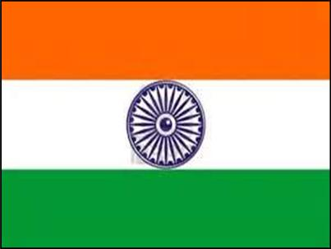
In order to understand this in a simple way, it was explained with a help of a picture of Indian National Flag. Each Colour bands in the flag denotes the following food groups:
- White - All the grains/cereals, bread, milk, potato
and other root vegetables.
- Yellow - All yellow food such as yellow vegetables, fruits, dhal & pulses, egg, meat etc.
- Green - Green leafy vegetables & other
vegetables.
- ‘Chakra’ - Oil & oil seeds
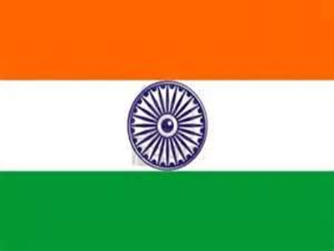
Therefore as in the case of national flag in which all the colour bands are in the right
Proportion, our daily diet should also be colourful & balanced.

Session 2: The vulnerable group
Some groups in our community are likely to get balanced diet and to suffer from malnutrition. They belong to the vulnerable group. Vulnerable group who require special attention for nutrition are as follows:
- Pregnant women
- Lactating mothers
- Infants – birth to one year
- Children – 1 to 3 yrs
- Children – 3 to 5 yrs
- Adolescent girls
Nutrition for pregnant women and lactating mothers:
Pregnancy is a demanding physiological state. In India, it is observed that diets of women from the low socioeconomic groups are essentially similar during pre pregnant, pregnant and lactating periods. Consequently, there is widespread maternal malnutrition leading to high prevalence of low birth weight infants and very high maternal mortality.
Additional foods are required to improve pregnancy weight gain and birth weight of infants, Pre-pregnancy BMI, maternal age and rate of pregnancy weight gain must be considered in tailoring the calorie recommendation to the pregnant women.
The daily diet of a woman should contain an additional 350 calories, 0.5 g of protein during first trimester and 6.9 g during second trimester and 22.7 g during third trimester of pregnancy. Some micronutrients are specially required in extra amounts during these physiological periods. Folic acid, taken throughout the pregnancy, reduces the risk of congenital malformations and increase as the birth weight. The mother as well as the growing foetus need iron to meet the high demands of RBC formation. Calcium is essential, both during pregnancy and lactation, for proper formation of bones and teeth of the offspring, for secretion of breast-milk rich in calcium and to prevent osteoporosis in the mother. Similarly, iodine intake ensures proper mental health of the growing foetus and infant. Vitamin A is required during lactation to improve child survival. Besides these, nutrients like vitamins B and C need to be taken by the lactating mother.
How can the pregnant and lactating women meet the additional nutritional demands?
- Eat a wide variety of foods to make sure that her own nutritional needs as well as those of her growing foetus are met.
- Quantity and frequency of usage of the different foods should be increased.
- Good quality protein is derived from milk, fish, meat, poultry and eggs.
- A proper combination of cereals, pulses and nuts also provides adequate proteins. Mineral and vitamin requirements are met by consuming a variety of seasonal vegetables particularly green leafy vegetables, milk and fresh fruits.

- Bioavailability of iron can be improved by using fermented and sprouted grams and foods rich in vitamin C such as citrus fruits.
- Milk is the best source of biologically available calcium.
- Take daily supplements of iron, folic acid, vitamin B and calcium.
- Adequate intake of a nutritious diet is reflected in optimal weight gain during pregnancy (10 kg) by the expectant woman.
- To avoid constipation should choose foods rich in fibre like whole grain cereals, pulses and vegetables and take plenty of fluids including 8-12 glasses of water per day.
- Excess intake of beverages containing caffeine like coffee and tea adversely affect foetal growth should be avoided.
- Should undergo periodic health check-up for weight gain, blood pressure, anaemia and receive tetanus toxoid immunization.
- Requires enough physical exercise with adequate rest for 2-3 hrs during the day. Pregnant and lactating women should not indiscriminately take any drugs without medical advice, as some of them could be harmful to the foetus/baby.
Nutrition for the infants:
- Breast-milk is the most natural and perfect food for normal growth and healthy
- development of infants and it provides the best nutrition
- Breast-milk is a natural food and is more easily digested and absorbed by the infant as compared to formula milk prepared from other sources.
- Colostrum which is the milk secreted during the first 3- 4 days after child birth, is rich in proteins, minerals, vitamins especially vitamin and antibodies is rich in anti-infective factors and should be fed to infants.
- Breast-feeding reduces risk of infections.
- It establishes mother-infant contact and promotes mother-child bonding.
- It prolongs birth interval by fertility control (delayed return of menstruation).
- Breast-feeding helps in retraction of the uterus.
- Incidence of breast cancer is lower in mothers who breast feed their children.
- Breast feeding is associated with better cognitive development of children and may provide some long-term health benefits.
- Mother-infant contact should be established as early as possible (immediately after birth) by permitting the infant to suck at the breast. Mothers can breast-feed from as early as 30 minutes after delivery. Colostrum should be made available to the infant immediately after birth.
- Feeding honey, glucose, water or dilute milk formula before lactation should be avoided and the infant should be allowed to suck, which helps in establishing lactation.
- A baby should be exclusively breast-fed only upto 6 months. Giving water or any other fluid to the infant should be avoided till the baby completes 6 months.
- Demand feeding helps in maintaining lactation for a longer time.
- Breast-feeding can be continued as long as possible, even upto 2 years
- Even the undernourished mothers can successfully breast-feed. But in the case of severe malnutrition, both the quality and quantity of breast-milk may be affected.
- Frequent sucking by the baby and complete emptying of breast are important for sustaining adequate breast milk output.
- A working mother can express her breast milk and store it hygienically upto 8 hrs. This can be fed to her infant by the caretaker.
Complementary Food:
- Breast-milk alone is not adequate for the infant beyond 6 months of age. Introduction of food supplements (semi-solid complementary foods) along with breast-feeding is necessary for infants after 6 months of age.
- Provision of adequate and appropriate supplements to young children prevents malnutrition
- Low cost food supplements can be prepared at home from commonly used ingredients such as cereals (whet/rice/ragi/jowar/bajra etc.); pulses (gram/dhals), nuts and oilseeds (ground nut, sesame etc.) oils, sugar and jiggery.
- Such supplements are easily digested by all infants, including those with severe malnutrition.
- Hygienic practices should be observed while preparing and feeding the food to the child; otherwise, it will lead to diarrhoea
- Flours of germinated cereals, which are rich in the enzyme alpha-amylase, constitute Amylase- Rich Foods (ARFs). Even small amounts of this type of foods liquefy and reduce the bulk of the cereal based diet. ARFs help in increasing the energy density of weaning gruels and in reducing its bulk as well.
- Mothers can add ARF to increase the digestibility of the low-cost weaning foods prepared at home. Preparation of ARF is very simple and can be done by mothers at home.

PREPARATION OF AMYLASE RICH FOOD (ARF)
Take 250 g of wheat/Ragi/Jowar/Bajra

Add 2-3 volumes of water soak it for 8 hrs

Drain excess water

Germinate wheat in dark for 24-48 hours

Sun dry for 5-8 hours

Roast gently in flat pan just to remove water
Grind and powder the grains (ARF)

Store in airtight bottles/jars
Add 5 g (one tea spoon) of ARF, after cooking, to every feed

Preparation of Sathu Maavu at home
Preparation of Sathu Maavu at home
Ingredients:
Ragi - 200 gms
Wheat or Jowar or Bajra or Boiled rice - 200 gms
Puffed Bengal gram dhal (Porikadalai) - 200 gms
Roasted ground nut - 100 gms
Sesame - 50 gms
Jaggery - 250 gms
Clean all the above ingredients separately. Soak ragi in sufficient water & allow it to sprout overnight. Roast sprouted ragi, wheat or bajra or jowar or rice, sesame (which ever you have taken) separately. Roast a table spoon of cumin seeds & 25 gm of cardamom. Allow the roasted ingredients to cool. Mix all the ingredients together (except jiggery). Grind the ingredients as a course powder using a mixie. Allow it to cool. Break the jiggery into small pieces and mix it with the sathu powder. Sore it in a water tight container.
Ingredients:
Ragi - 200 gms
Wheat or Jowar or Bajra or Boiled rice - 200 gms
Puffed Bengal gram dhal (Porikadalai) - 200 gms
Roasted ground nut - 100 gms
Sesame - 50 gms
Jaggery - 250 gms
Clean all the above ingredients separately. Soak ragi in sufficient water & allow it to sprout overnight. Roast sprouted ragi, wheat or bajra or jowar or rice, sesame (which ever you have taken) separately. Roast a table spoon of cumin seeds & 25 gm of cardamom. Allow the roasted ingredients to cool. Mix all the ingredients together (except jiggery). Grind the ingredients as a course powder using a mixie. Allow it to cool. Break the jiggery into small pieces and mix it with the sathu powder. Sore it in a water tight container.

Why the first 1000 days are important?
The first 1,000 days between a woman’s pregnancy and her child’s 2nd birthday offer a unique window of opportunity to shape healthier and more prosperous futures. The right nutrition during this 1,000 day window can have a profound impact on a child’s ability to grow, learn, and rise out of poverty. It can also shape a society’s long-term health, stability and prosperity.

In 1,000 days, you can change the future
By focusing on improving nutrition for mothers and children in the 1,000 day window, we can help ensure a child can live a healthy and productive life. Investing in better nutrition in the 1,000 day window can also help families, communities and countries break the cycle of poverty.
Evidence shows that the right nutrition during the 1,000 day window can:
- Save more than one million lives each year;
- Significantly reduce the human and economic burden of diseases such as tuberculosis, malaria and HIV/AIDS;
- Reduce the risk for developing various non-communicable diseases such as diabetes, and other chronic conditions later in life;
- Improve an individual’s educational achievement and earning potential; and,
- Increase a country’s GDP by at least 2-3 percent annually.

Session 3:
Nutrition for adolescent girls:
Adolescent period is spread almost over a decade. It is characterized by rapid increase in height and weight, hormonal changes, sexual maturation and wide swings in emotion. Adolescent growth spurt starts at about 10-12 years in girls and two years later in boys. The annual peak rates for height and weight are 9-10 cm and 8-10 kg. Development of critical bone mass is essential during this period as this forms the ground for maintaining mineral integrity of the bone in later life. The pattern and proportion of various body components like body water, muscle mass, bone and fat increase during the entire childhood and adolescence to reach adult values by about 18 years. Adolescent girls are at greater physiological stress than boys because of menstruation. Their nutritional needs are of particular importance as they have to prepare for motherhood. All these rapid anabolic changes require more nutrients per unit body weight.
Anaemia during adolescence:
Anaemia is a critical public health problem in India that affects women and children throughout the lifecycle. Anaemia in boys and girls limits their development, learning ability, reduces concentration in daily tasks, increases their vulnerability to infection, increases school dropout rates, reduces physical fitness and work productivity. Anaemia in girls during pregnancy is associated with premature births, low birth weight, and peri-natal and maternal mortality.

Intergenerational cycle of Anaemia
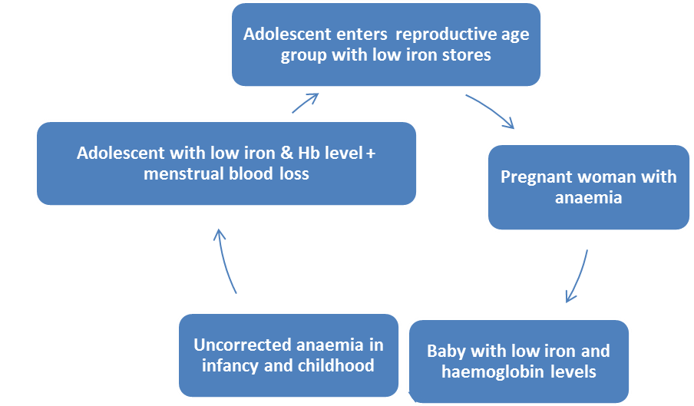

What is anaemia?
Human blood contains a red pigment called haemoglobin, which is rich in iron. It carries oxygen to different parts of body. Deficiency of iron in diet leads to decreased amount of haemoglobin, making the blood thin and less red in colour which leads to less supply of oxygen to different parts of the body; this state is known as anaemia.

CAUSES AND EFFECTS OF ANAEMIA
There are many different types of anaemia. They could be nutritional or non -nutritional causes (heavy/chronic bleeding, infections, genetic disorders or cancers). Nutritional anaemia, particularly, is the most widely prevalent form of anaemia in the country.

Causes of Iron Deficiency Anaemia and nutritional anaemia are:
- Poor Dietary intake of iron resulting in deficiency of iron in the body and thus
- Iron deficiency anaemia (less intake of iron rich foods; Gender discrimination in food
- allocation in a family aggravates the situation)
- Low bio-availability of iron- Habitual intake of cereal based diet high in phytate
- and poor consumption of iron absorption enhancers such as vitamin C result in
- low availability of iron.
- Dietary deficiency of vitamins such as Folic Acid, Vitamin C, Vitamin B12
- Non nutritional causes of anaemia:
- Accelerated increase in requirement for iron during adolescent period
- Hookworm infestation, Infections such as Malaria
- Loss of blood in case of heavy menstrual bleeding.
- Teenage marriage and early pregnancy
Signs and Symptoms of anaemia:
- Whiteness or pallor in the inner rims of the eyelid, tongue, overall skin, nails & palms of the hand
- Soreness of the mouth, with cracks at the corners.
- Dizziness, tiredness, fatigue and low energy
- Unusually rapid heartbeat, particularly with exercise
- Shortness of breath and frequent headaches, particularly with exercise
- Lack of interest in play and studies
- Difficulty/ inability to concentrate
- Leg cramps
- Lowered resistance to infections
Prevention and control of anaemia:
- Eat balanced diet. Eating a balanced diet means consuming different types of food items like pulses, chapatti or rice, green vegetables, locally available fruits and milk every day.
- Take food rich in iron every day. Foods rich in iron are Green vegetables and fruits, Grains-
- wheat, jowar, bajra, sprouted pulses, ground nut, sesame, jaggery, dried fruits, Liver, egg, fish and meat
- Vitamin C rich foods help in absorption of iron. Citrus fruits (oranges, lemon),
- Indian gooseberry (Amla), apple, pear are rich in vitamin C.
- Take iron tablets distributed through ICDS/PHC once a week without fail.
- Avoid open-air defecation and use only sanitary latrines
- Use chappals while going out.
- Get deworming drugs from PHC and dewormed once in 6 months
- Follow healthy habits & personal hygiene.
- Use clean sanitary towels & dispose them properly

The participants were asked to visit an Anganwadi Centre and a Primary Health Centre and learn from the functionaries the activities of ICDS & PHC to ensure malnutrition free community. This was given as a home work assignment.

Nutrition tips:
• Take one or more cereals - one cereal other than rice every day.
• Take atleast one dhal/pulse every day. In case rasam is prepared, use any dhal along with vegetable.
• Use sufficient quantity of atleast one vegetable a day. It is good to take green leafy vegetables twice a week.
• Take any fruit—tomato, papaya, chikki, babna or any other locally available seasonal fruit every day.
• Have one salad with raw vegetables - onion, radish, cucumber, carrot, beat root and tomato.
• Mix any vegetables (chopped carrot or radish or mint leaves or coriander leaves in chapathi dough.
• Add vegetables while making sundal, kitchadi etc.
• Prepare pongal with wheat rava & whole greengram.
• Take sprouted beans, cereals and grams once a week.

Nutrition tips:
- Take one or more cereals - one cereal other than rice every day.
- Take atleast one dhal/pulse every day. In case rasam is prepared, use any dhal along with vegetable.
- Use sufficient quantity of atleast one vegetable a day. It is good to take green leafy vegetables twice a week.
- Take any fruit—tomato, papaya, chikki, babna or any other locally available seasonal fruit every day.
- Have one salad with raw vegetables - onion, radish, cucumber, carrot, beat root and tomato.
- Mix any vegetables (chopped carrot or radish or mint leaves or coriander leaves in chapathi dough.
- Add vegetables while making sundal, kitchadi etc.
- Prepare pongal with wheat rava & whole greengram.
- Take sprouted beans, cereals and grams once a week.

Day Four (19-01-2013)
Session 1: Safe food and proper cooking methods
Venue: Pudupakkam
- Selection of right type of food
- Purchasing
- Storing
Selection of the right food is the first Food grains purchased should be free from foreign matter and infestation (rodent excreta and insect remains). They should be of uniform size and should not be shrivelled, shrunken and mouldy. Foodstuffs should be free from artificial colours. There is a risk of adulteration when fats/oils are purchased loose from unsealed containers. Therefore, it is always safer to purchase reputed brand products in sealed sachets/containers. It is necessary to buy pasteurized milk in sachets from a reputed dairy or a reliable vendor to avoid the risk of adulteration and contamination. Milk products such as butter, ghee and khoa should also be purchased from Reliable sources. Whole spices, uniform in colour, size and shape should be preferred. Since powdered spices are more likely to be adulterated, always buy certified products. Fruits and vegetables that show patches, mechanical damage and bruises, or are wilted and decayed with visible evidence of insects and moulds, should be avoided. Eggs should be fresh and free from cracks. Meat or poultry must be examined for characteristic colour, odour and texture, and should be purchased fresh or frozen.
Personal Hygiene:
Food handlers should observe good personal hygiene to maintain food safety. They should be free from obvious signs of illness, wounds and sores. Traditionally in India, cooked food is touched by the hands while preparing, serving and eating. Use of spoons and ladles should be encouraged to avoid contamination. Hands should be washed thoroughly before starting the preparation of food and after every interruption. Household pets like cats and dogs often harbour dangerous pathogens. They should be kept away from places where food is cooked, stored or served
Points to remember before and during cooking:
- Never wash the vegetables after cutting. Always clean the vegetables (specially greens), wash it & then cut it.
- Do not cut the vegetables in small pieces.
- Wash the vegetable well before cooking
- Do not waste the extra water of cooked vegetables. Always use minimum or sufficient amount.
- Do not over cook food specially vegetables.
- Use always less oil for cooking. Use oil with poly unsaturated fatty acids such as vegetable oil, sunflower oil, sesame oil or ground nut oil or rice bran oil.
- Avoid precooked food, junc food or fast food. Food items prepared with maida does not contain any nutrients except calories.
- Never reheat oil. It may cause cancer.
- Use always iodised salt.
- Grow vegetable garden.

Session 2: Getting know about ICDS & Primary Health Centres
Integrated Child Development Services (ICDS)
Organisational chart activities of the Centre:

Child Development Project Officer (CDPO) (At the Block level)

Grade I Supervisor (At the Block level)

Grade II Supervisor (At the sector level)

Anganwadi Worker & Helper (At the village level)

- For every 500 to 1000 population an Anganwadi Worker (AWW) and a Helper is appointed.
- She takes a household survey of her area
- Identifies the beneficiaries - pregnant women, nursing mothers, children < 3 yrs, children 3—5 yrs and adolescent girls
- All children < 3 years are weighed once a month & 3-5 years children once in 3 months.
- The weight is plotted in the Mother Child Protection Card (MCP Card). At the time of antenatal registration every mother is given a MCP Card by the Village Health Nurse. All the services rendered to the mother & the baby are recorded in the Card till the baby is 3 years old.
- While plotting the weight in the Card, if the child is found to be under nourished (If the baby is not having adequate weight), the child is referred to the Village health nurse/ PHC.
- Children 6 months to 3 years are given ‘Sathu Urundai’ in the morning. The number of Urundai depends on the nutrition status of the child.
- For the children 3 to 6 years are given noon meal
- AWW conducts preschool for children 2+ to 5+
- She makes home visits, conducts mothers classes, organises group meetings & campaigns.
- Helps the Village health Worker to organise antenatal clinics, immunisation for the children, post natal visits, distribution of Vitamin A solution & deworming drugs to children.

Primary health Centres (PHCs)
- In every rural block 3 or 4 PHCs are established according to the population of the block. One will be a Block PHC
- Each PHC caters to a population of around 30,000.
- For each PHC 2 Medical Officers are appointed, one will be a Woman Medical Officer.
- For every 5000 population a Health Sub Centre (HSC) is established and a residential
a Village health Centre (VHN) is posted.
- VHN is responsible for Mother & Child Care and provides nutrition services also.
At the Block level other departments such as Education, Revenue, Social Welfare etc which are looking after the welfare of the people.

How to coordinate with ICDS & PHC to ensure nutrition well being of the people:
- Get involved in their educational programmes.
- Invite the block level, sector level Supervisors for the special programmes of NGO.
- Identify those who are left out for Nutrition or health services such as weighing of children, those who are under nourished but not receiving urundai, children not immunised, children not attending preschool and report to AWW/VHN
- Organise joint campaigns and training programmes
The participants then shared some of the observations in the AWC and HSC which are not encouraging. They were told that NGO staff have a moral responsibility of observing the functioning of these Centres and have a healthy dialogue with the functionaries. They must also inform the community about their responsibility to monitor the activities and extend their help for proper functioning.

Day Five (05-02-2013)
Session 1:
Venue: Karanodai
Recommended dietary allowances for Indians:

Group | Particulars | Body  wt. kg | Net Energy  Kcal/d | Protein  g/d | Visible  Fat  g/day | Calcium  mg/d | Iron  mg/d
Man | Sedentary work | 60 | 2320 | 60 | 25 | 600 | 17
 | Moderate work |  | 2730 |  | 30
 | Heavy work |  | 3490 |  | 40
Woman | Sedentary work | 55 | 1900 | 55 | 20 | 600 | 21
 | Moderate work |  | 2230 |  | 25
 | Heavy work |  | 2850 |  | 30
 | Pregnant woman |  | +350 | 82.2 | 30 | 1200 | 3 5
 | Lactation  0 – 6 months |  | +600 | 77.9 | 30 | 1200 | 25
 | Lacttion  6 - 12 months |  | +520 | 70.2 | 30
Infants | 0-6 months | 5.4 | 92 Kcal/kg/d | 1.16 g/kg/d | - | 500 | --
 | 6-12 months | 8.4 | 80 Kcal/kg/d | 1.69 g/kg/f | 19 |  | 46 μg/  kg/day
Children | 1 – 3 yrs | 12.9 | 1060 | 16.7 | 27 | 600 | 09
 | 4 – 6 yrs | 18 | 1350 | 20.1 | 25 |  | 13
 | 7 – 9 yrs | 25.1 | 1690 | 29.5 | 30 |  | 16
Boys | 10 -12 yrs | 34.3 | 2190 | 39.9 | 35 | 800 | 21
Girls | 10 -12 yrs | 35.0 | 2010 | 40.4 | 35 | 800 | 27
Boys | 13 – 15 yrs | 47.6 | 2750 | 54.3 | 45 | 800 | 32
Girls | 13 – 15 yrs | 46.6 | 2330 | 51.9 | 40 | 800 | 27
Boys | 16 -17 yrs | 55.4 | 3020 | 61.5 | 50 | 800 | 28
Girls | 16 -17 yrs | 52.1 | 2440 | 55.5 | 35 | 800 | 26

Session 2: Physical exercises
The participants were then taught simple physical exercises to keep themselves healthy. They eagerly learnt the exercises.
Session 3: Reflections on the training
The participants were given white papers. One by one the questions were read out & they were asked to write the answers/comments. They were told not to write their names on the answer sheets. After they completed writing, the papers were collected, shuffled & redistributed to them for correction.
The following are the remarks and comments on training:
1. New points/facts learnt:
- Balanced diet and importance of taking nutritious food
- Greens is also a vegetable; it should be consumed preferably daily.
- Daily recommended dietary allowance for each age group
- Nutrients in every food stuff
- Nutritionally vulnerable and importance of nutrition for adolescent girls.
- First 1000 days in children’s life
- Mother Child Protection Card
- Physical exercises
- Food pyramid
- Anti oxidants
- Reducing the rice intake
- Avoiding to take food items prepared with maida
- Iodised salt
- Reducing the intake of oil
2. Refreshing what was already known:
- Functions of Anganwadi Centre
- What was learnt in Health training
- Understanding nutrition through ‘National Flag’
- Importance of plotting in the MCP Card.
3. Behaviour changes in the personal life:
- Started taking other cereals and grains
- Avoiding precooked/fast food stuff such as noodles, pizza etc.
- Consuming sufficient quantity of vegetables every day
- No more food taboos (Heat or cold or gassy food) Started taking all vegetables & fruits
- Right method of boiling & drinking milk
- Reduced use of oil specially oil with saturated fatty acids
- Every day atleast one vegetable
- Started taking calcium tablets
- Started using iodised salt only
- Drink ’Sathumavu Kanchi’ instead of coffee
- Clean & cook without wasting nutrients
- Consume curd every day
- Take atleast one fruit every day
- Take less sugar
- Monitor Anganwadi Centre
4. How to take the lessons learnt to the local community?
- Celebrate village nutrition day
- Plan for training of SHG members
- Training of adolescent girls
- Organise Village Health and Nutrition Day
- Organise campaigns
5. What are the requirements?
- Training modules
- Charts and educational materials
Summing up session:
The training programme was summed up after an open discussion with Mr. JothiRamalingam. The participants shared their idea for taking this training to the next level and ultimately to all the SHG members. Tentative dates fixed for conducting pilot training in few areas.
Ms. Annie Valsarajan thanked Mr. JothiRamalingam, for giving her an opportunity to organise the training programme and for providing all the facilities. She appreciated all the participants for their Co-operation and continuous interest shown to learn about nutrition.

